Date: Friday 10th July 2020
Good morning Wells class!
Session 1: Handwriting and DT:
We are going to practice writing some of our common exception words. This is so that we practice reading them and practice our cursive handwriting. You can write your words in your lined book and then get an adult to check that your handwriting is neat, cursive, that your ascenders are tall and your letters are all the same size. Here are today’s words. 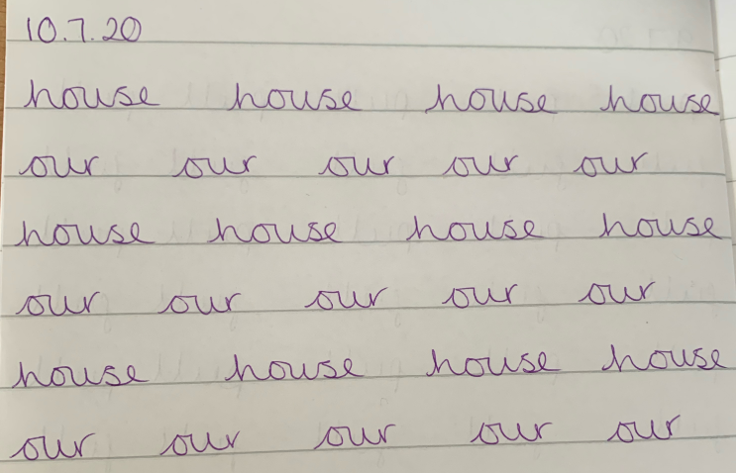
How did your sewing go yesterday?
We are going to make our puppets today. This might take most of the morning.
You will need fabric (we are using felt), scissors, needle and thread.
First you will need to draw around the template and cut two pieces of fabric.
Then use your favourite stitch, running or over cast to sew your two pieces of fabric together around the edge. Remember to leave the bottom unsewn so that your hand can go in.
It is easier if you pin your two pieces of fabric together.
Now enjoy a break!
Brain Break 15 minutes- time outside in the garden or doing something on the ‘Things to keep Active’ document. You could have a snack.

Session 2: DT:
Now it is time to decorate your puppet!
You could cut other pieces of fabric and glue them onto your puppet or you could decorate your fabric with pens.

Lunch Break: Enjoy a break from learning, get some movement time in too.

Session 3: DT:
Now we need to evaluate our puppets. That means we celebrate the good things about them and say if anything needs to be improved.

Puppet Evaluation

Have you followed your plan? _______________________________________
What was favourite part?
_______________________________________What did you find difficult?
_______________________________________
Did you enjoy making your puppet?
_______________________________________

Other activities to fill the day:
- You can play games on the Phonics play website.
- You can do a Just Dance or a Joe Wicks workout.
- You could play Hit the button to practise your number bonds to 10.
- You can do some reading on Oxford owl.

